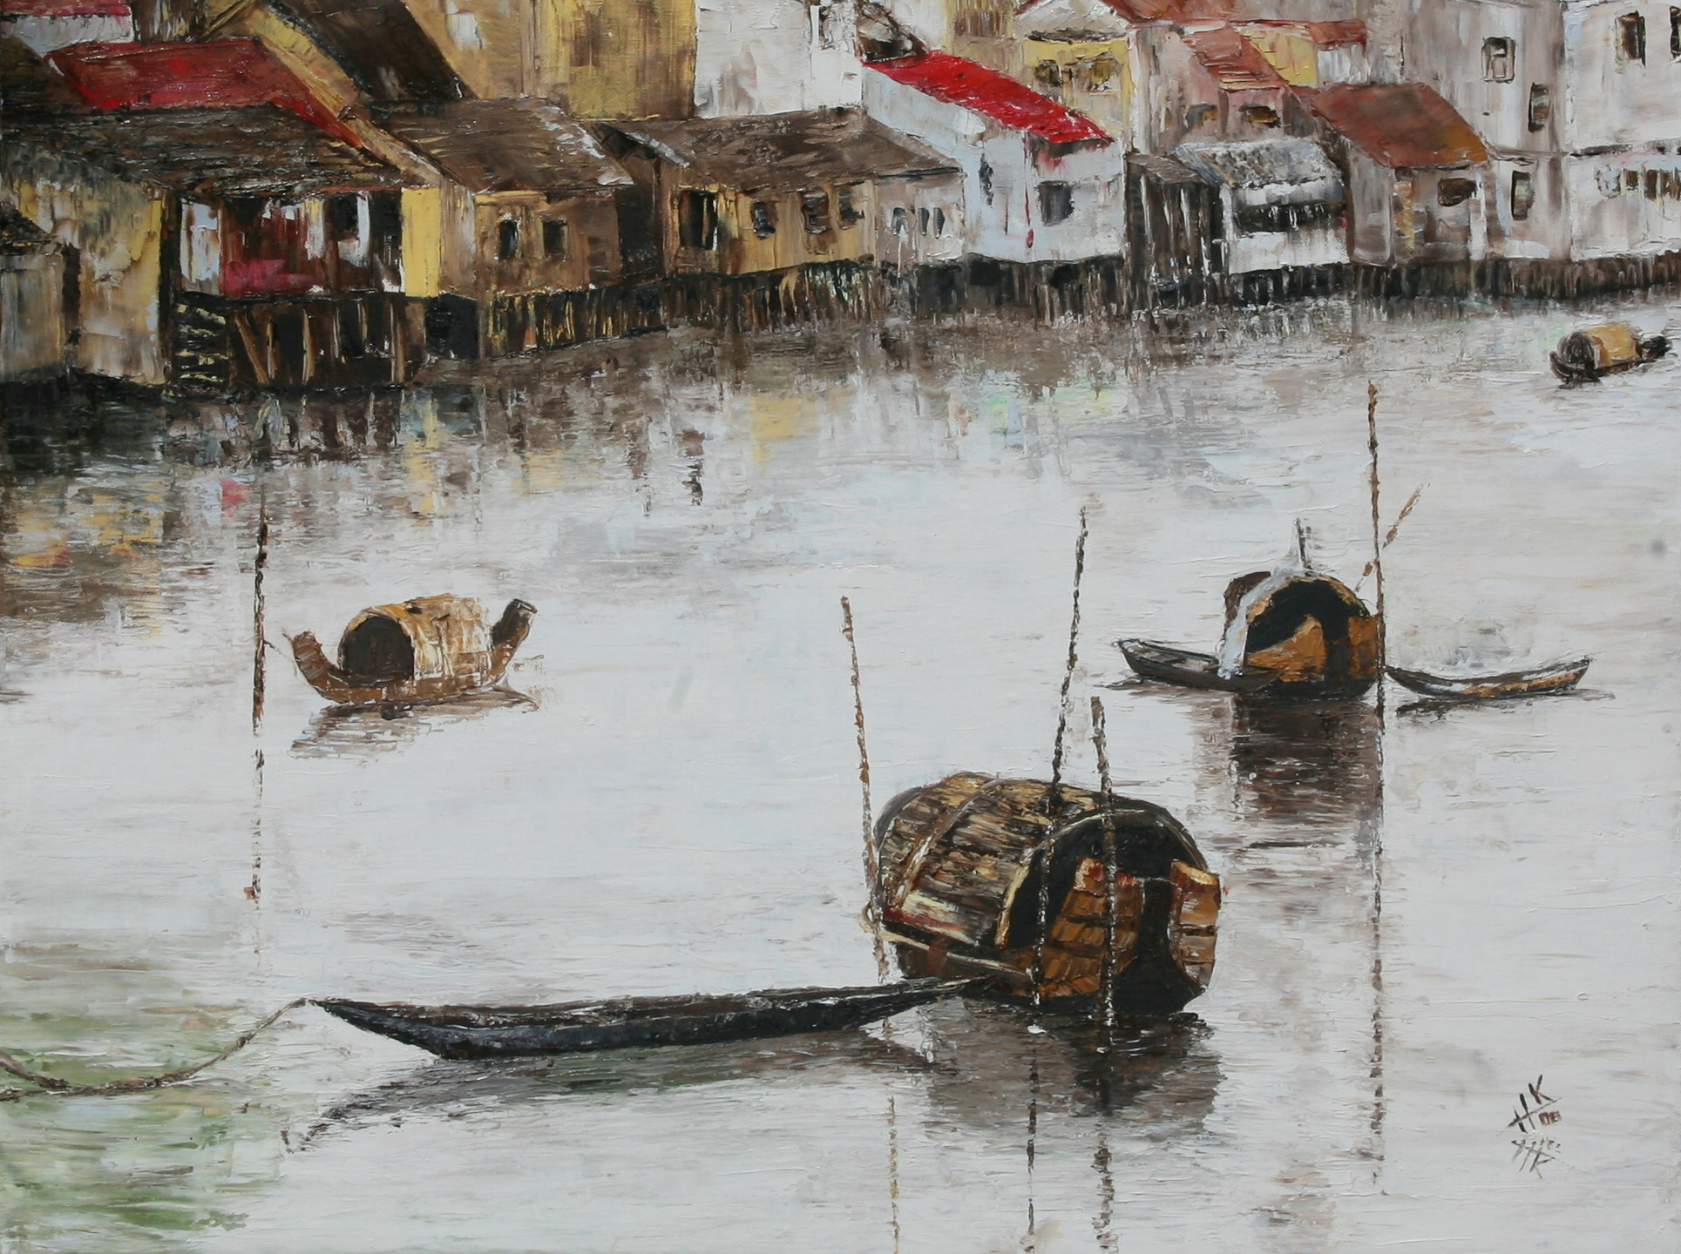
Oil painting by Hélène KLING
Vernissage

Hélène KLING,
has the pleasure to invite you to a cocktail reception for the vernissage of her painting exhibition

EVANESCENCE

On Wednesday April 22nd at 6.30 pm

At the Gallery An An
109 Dong Khoi Street, D1, HCMC

The exhibition will be held from the Wednesday 22 nd April 8 am to the 23 rd 8 pm.

We can visit Helene KLING’s painting and
Her work place on appointment, just call 0903955780.
Or email
helene_kling@yahoo.com

513 street 12 An Binh
District 2, An Phu
Ho Chi Minh City
www.helenekling.com

